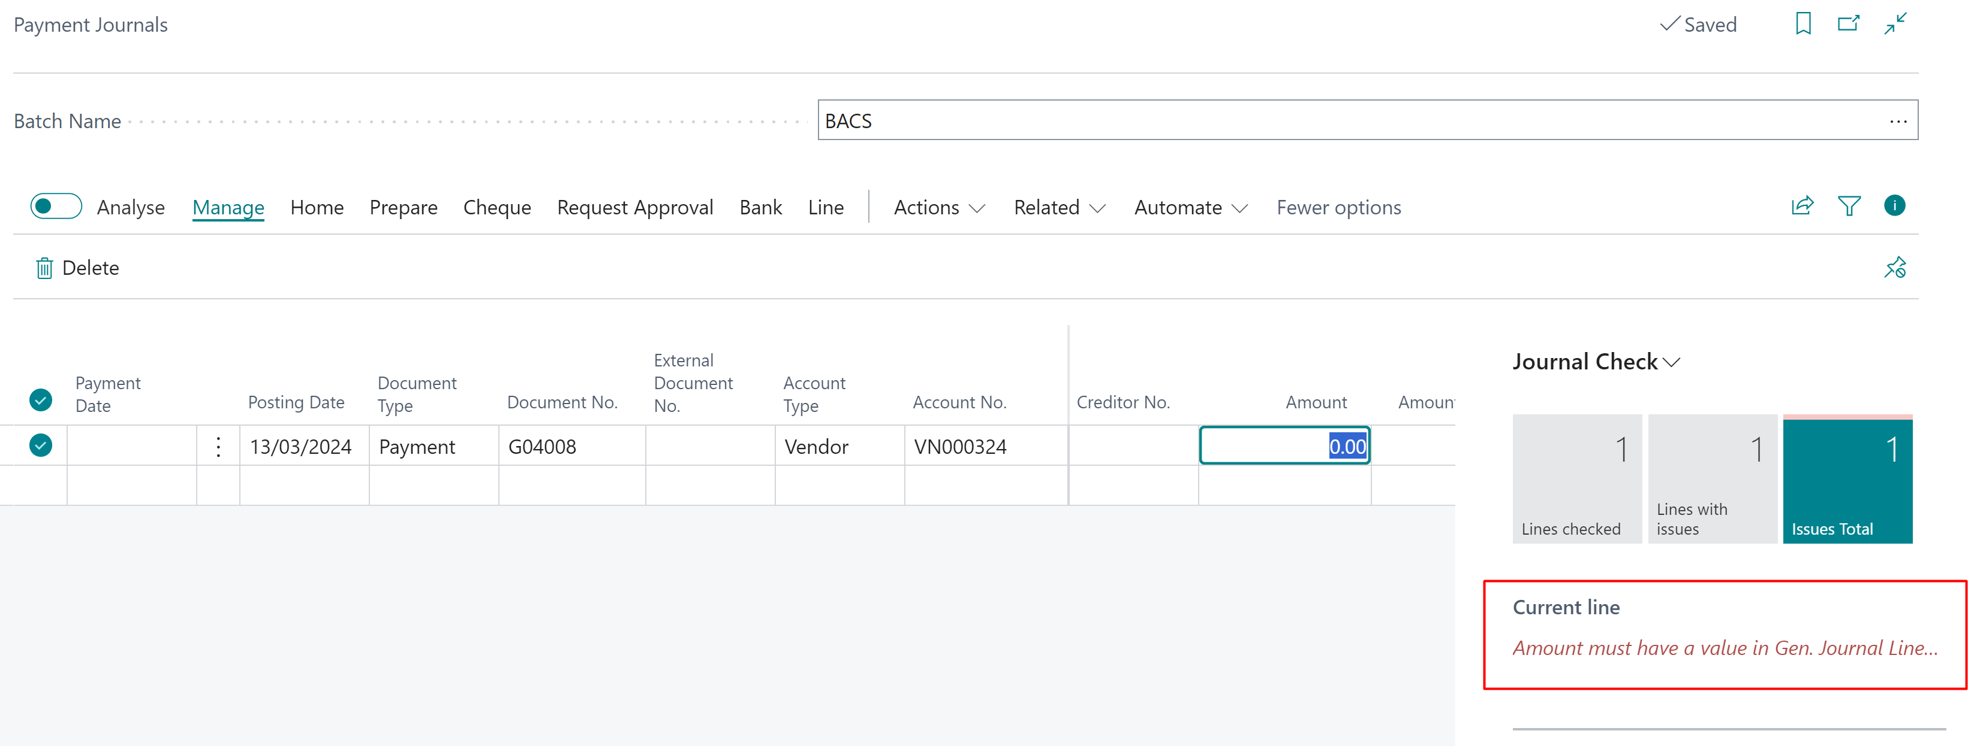
If you enter Amount manually the “Journal Check” disappears
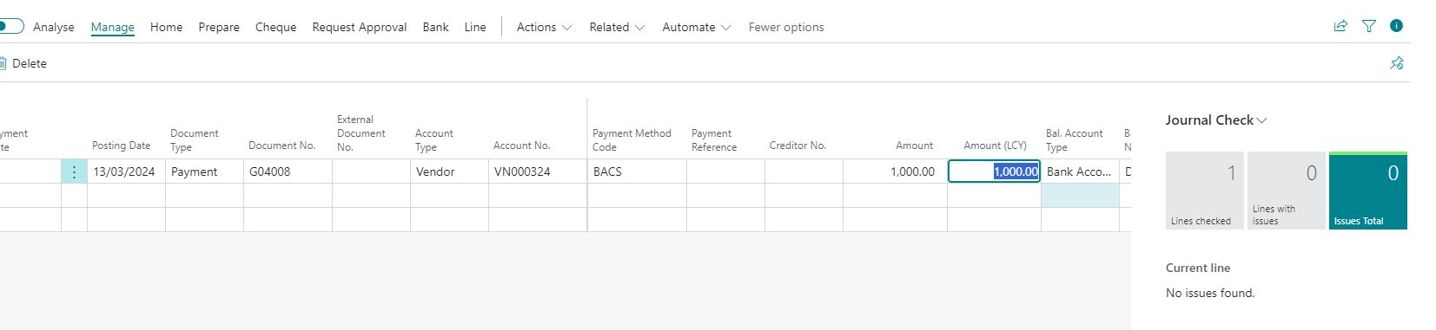

If however you use the “Apply Entries” which sets the Amount then the error does not clear
